BAREFOOT IN THE PARK
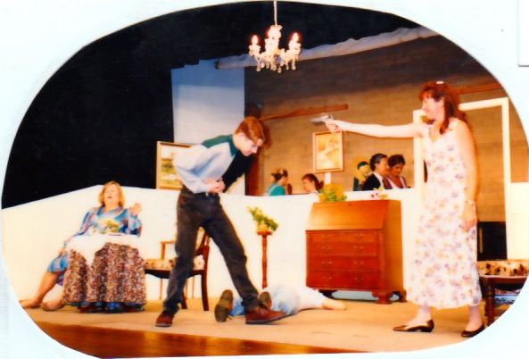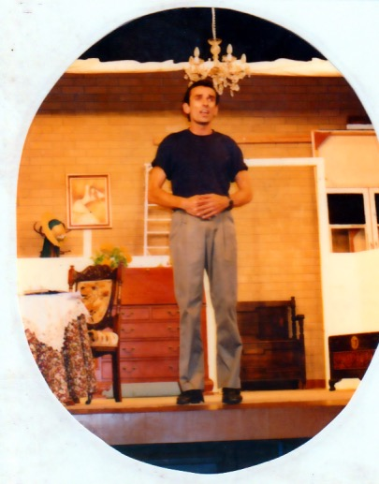
Production Team
Producer – Alma Bathgate
CAST  CORRIE BRATTER – Julie Withers  TELEPHONE MAN – Alan Wiliams  PAUL BRATTER – Cyril Wray  DELIVERY MAN – Barry Trotter  MRS BANKS – Joan Williams  VICTOR VELASKO – Malcolm Smith | CREW  Stage Manager – Alan Williams  Assistant Stage Manager – Charles Holmes  Props – Jill Roberts  Prompt – Margaret Bourke  Front Of House – Ross Reid

