**CONVERSATION WITH A GOLLIWOG**

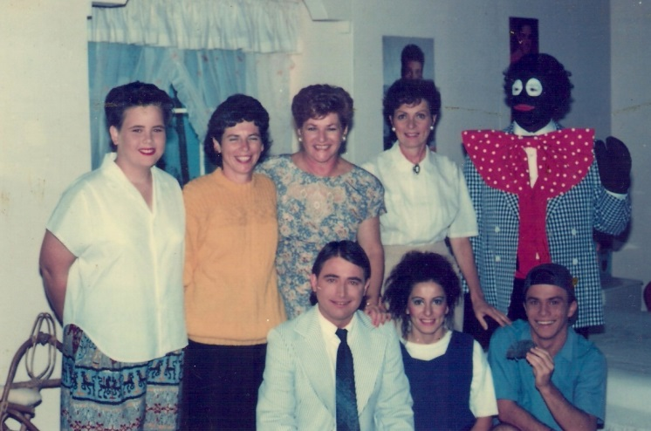 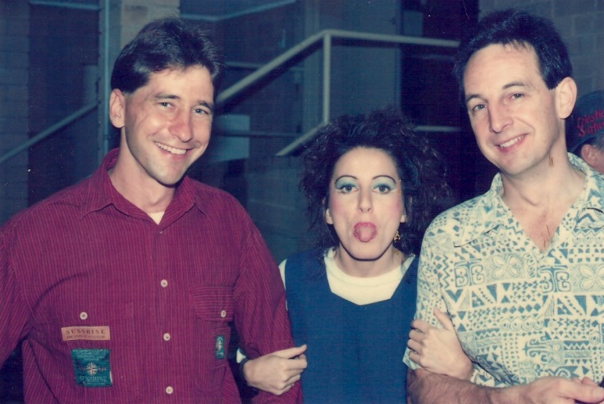

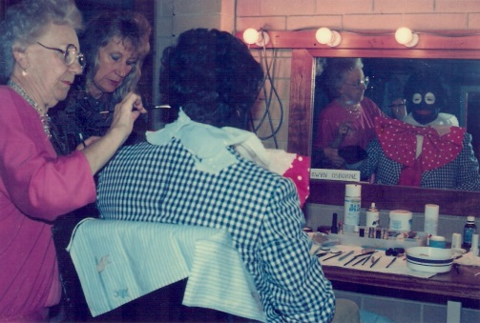 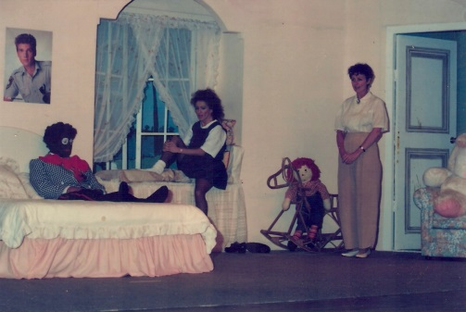 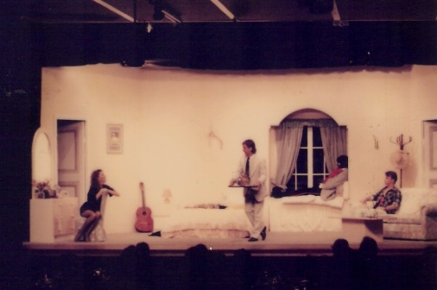

**Production Team**

**Director – Fran Legge**

**Musical Director -**

**Choreographer -**

**Production Manager -**

|  |  |
| --- | --- |
| **CAST** | **CREW** |