**GONE TO BALI**

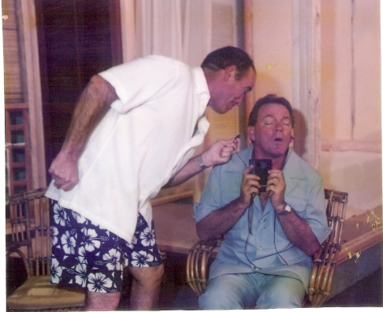 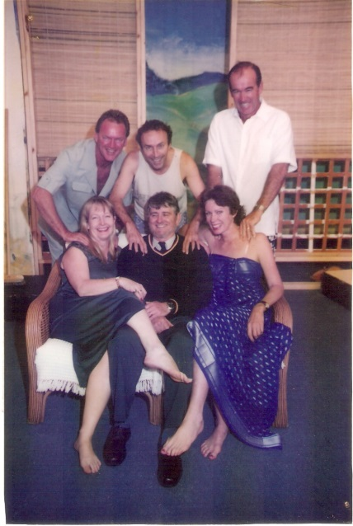 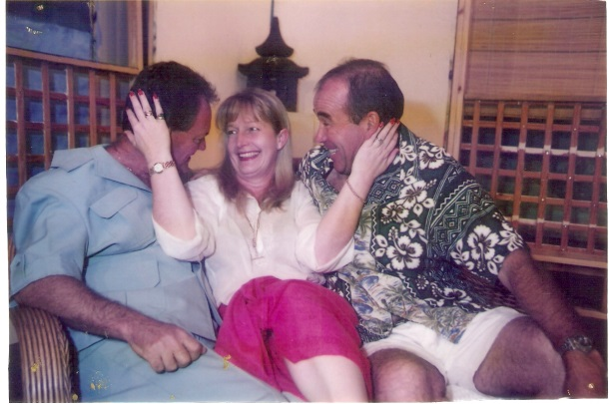

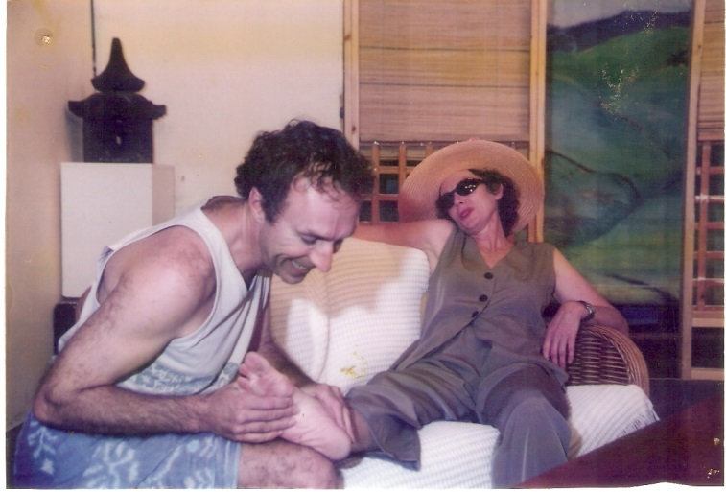 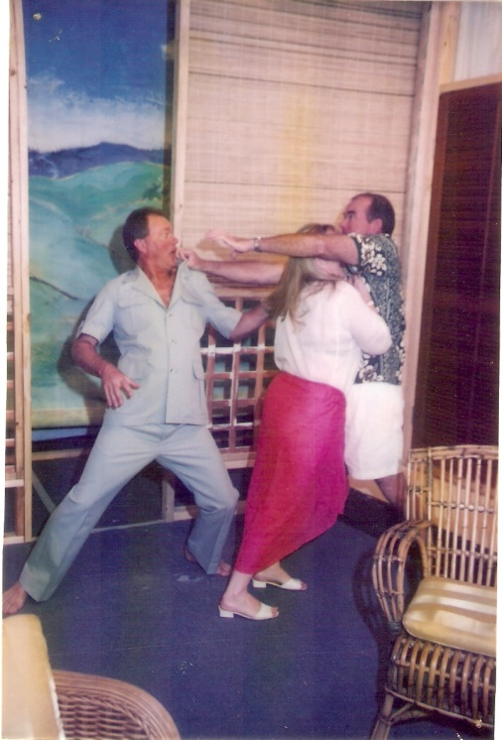

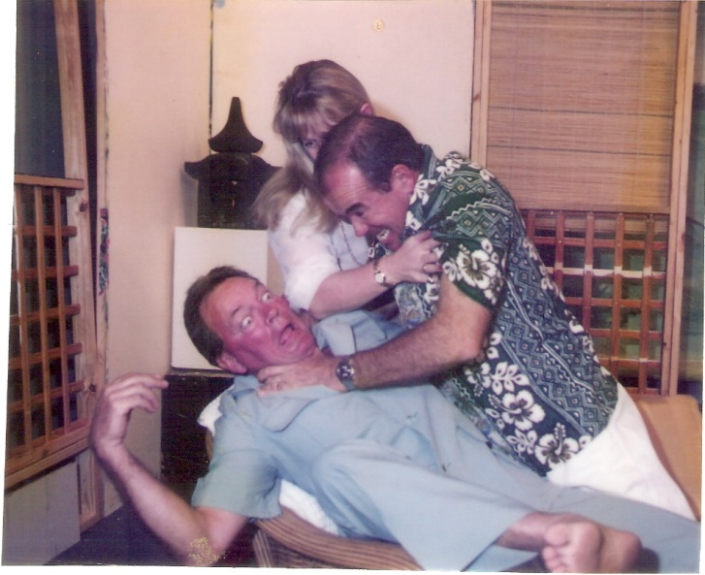

**Production Team**

**Director – Allen Ennew**

|  |  |
| --- | --- |
| **CAST**   * Di Ennew * Rob Geaney * Steve Woodfield * Bill Graham * Louise Forbes | **CREW** |