**KINDLY KEEP IT COVERED**

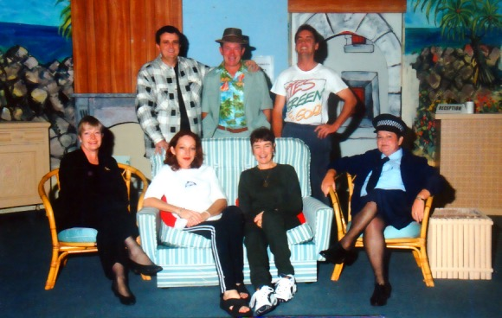

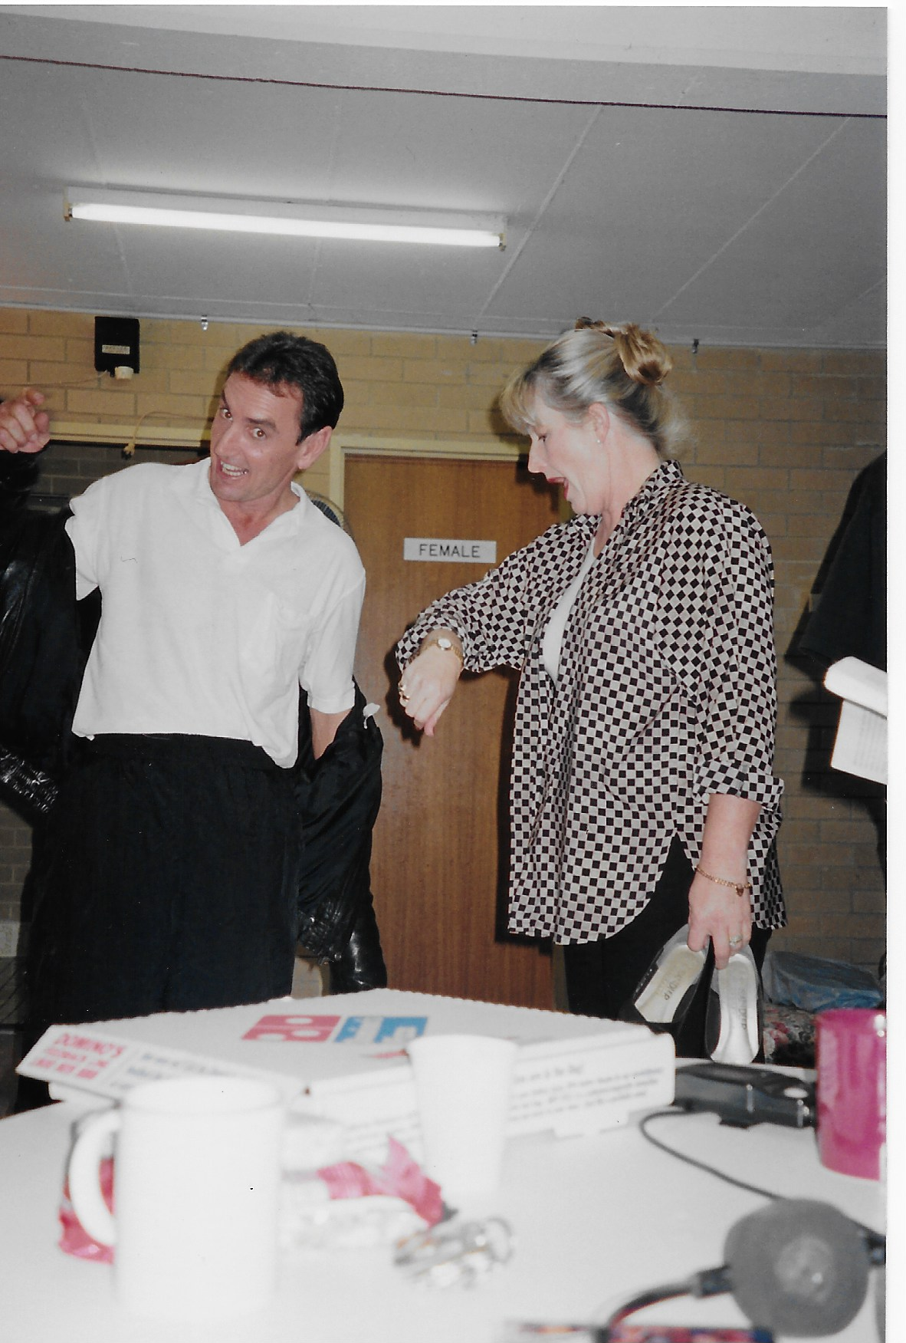 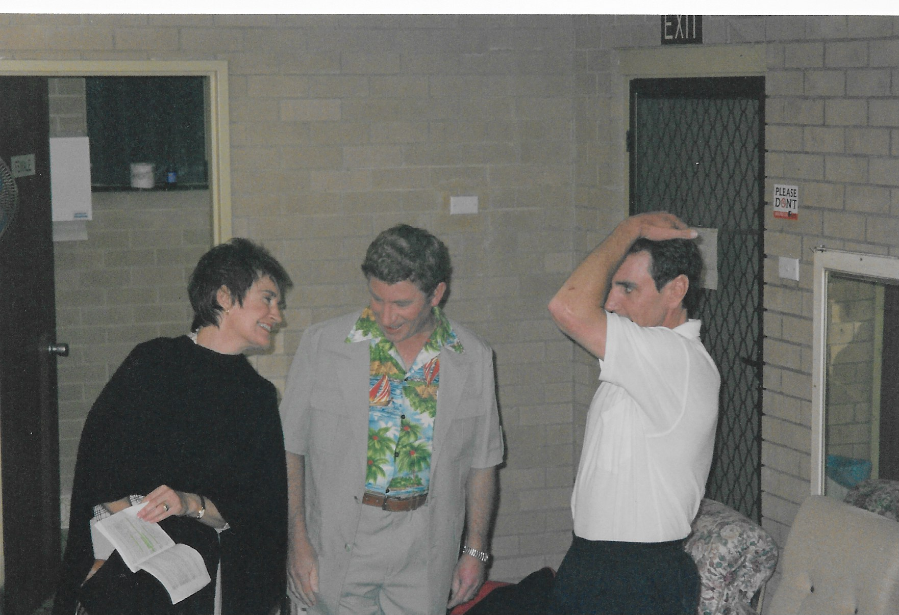 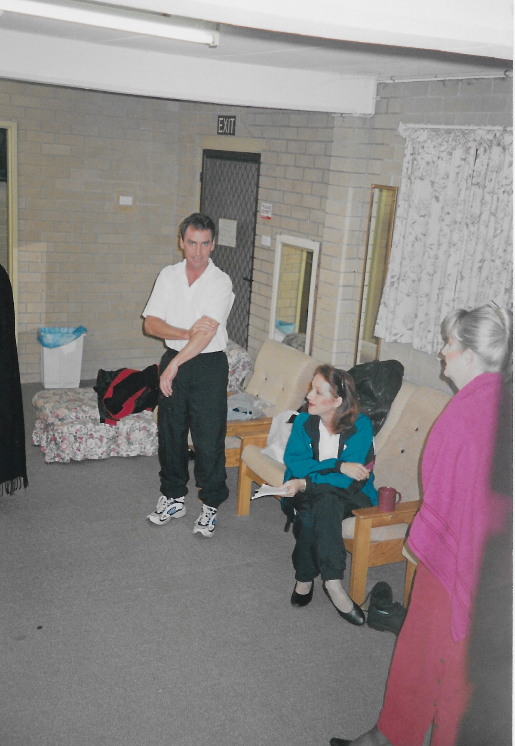

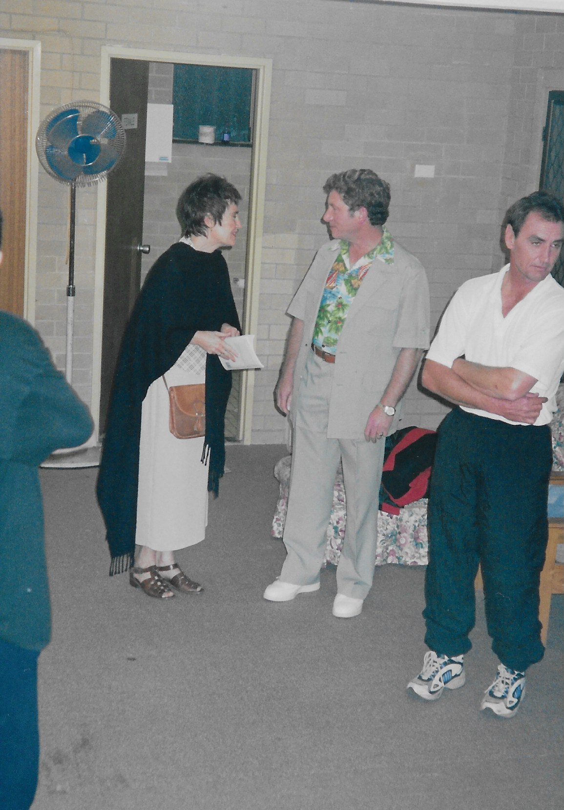 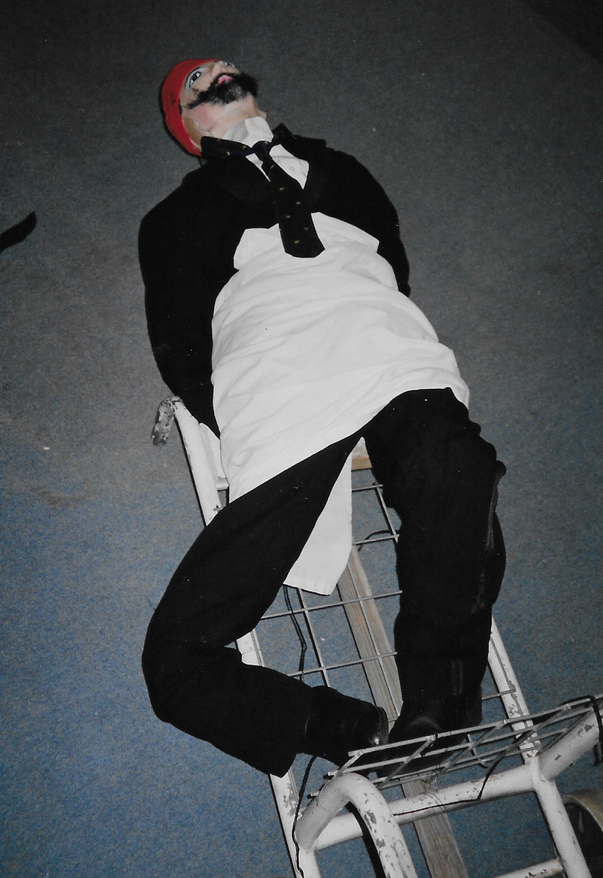 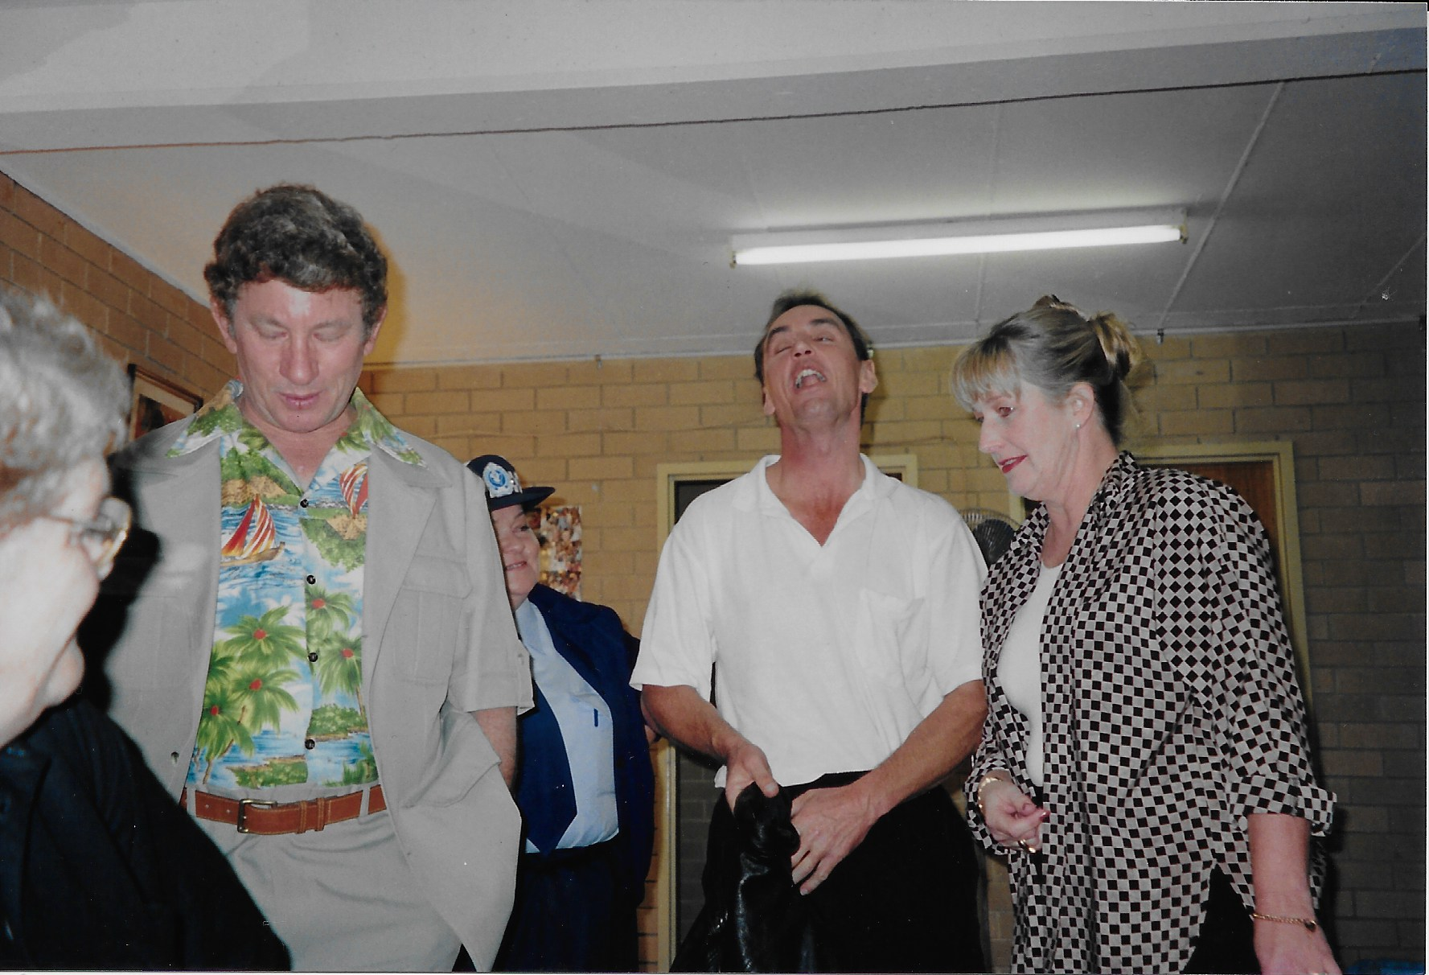

**Production Team**

**Director – Barbara Courtenay & Robin Quinlivan**

|  |  |
| --- | --- |
| **CAST**   * Liz May * Di Ennew * Moya Telfer * Dick McCoy * Craig Evans * Kevin Santin * Pamela Taylor | **CREW** |