GEORGY GIRL
THE SEEKERS MUSICAL
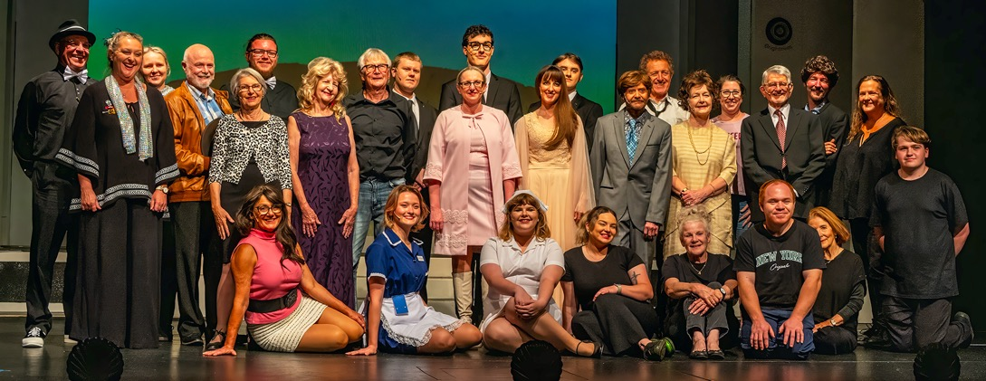
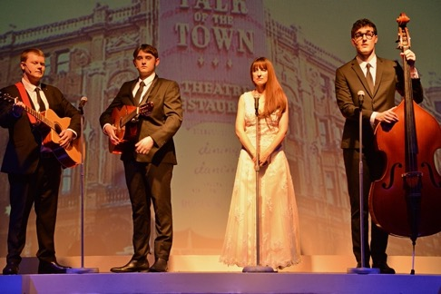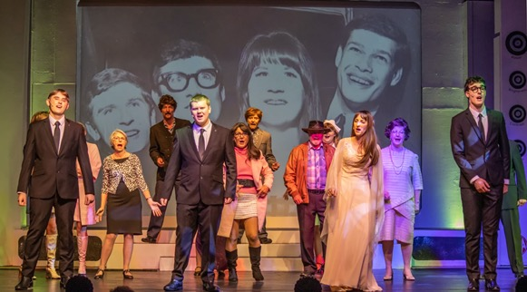
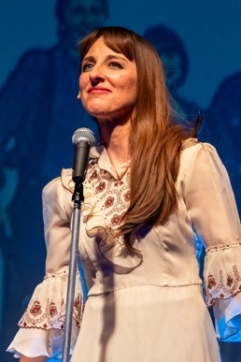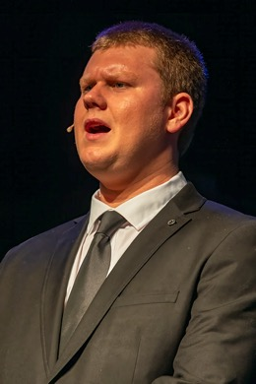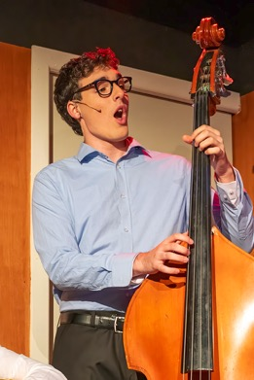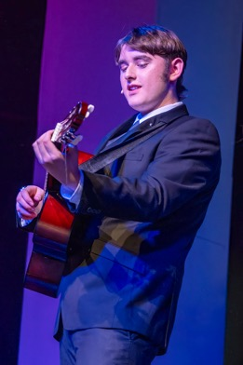
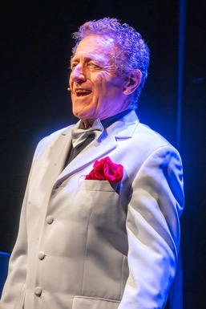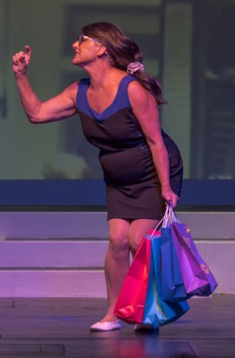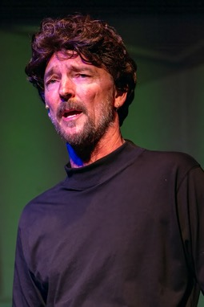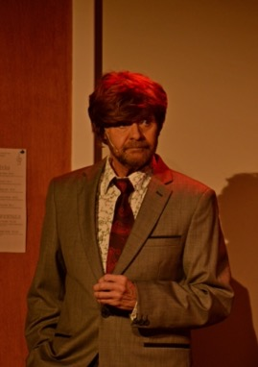
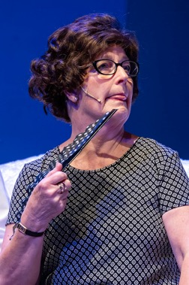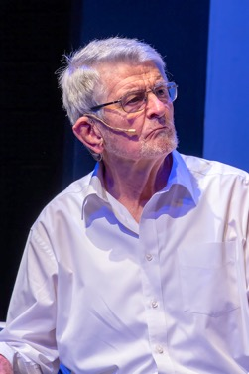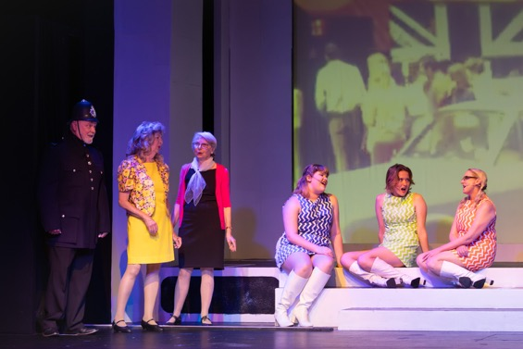
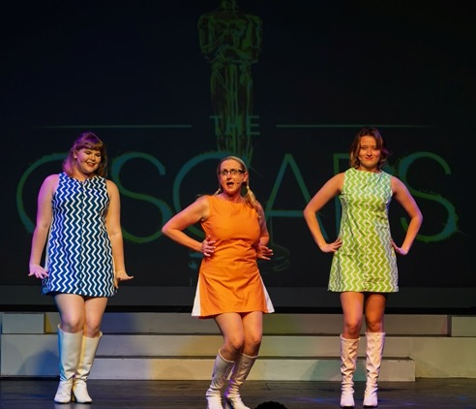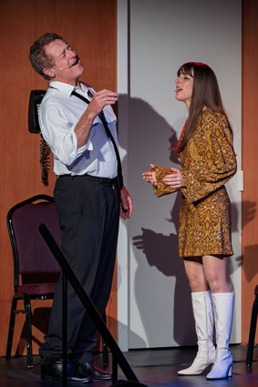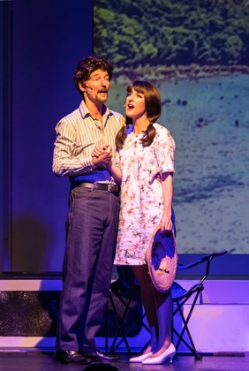
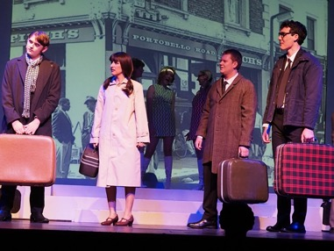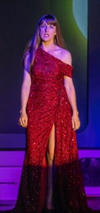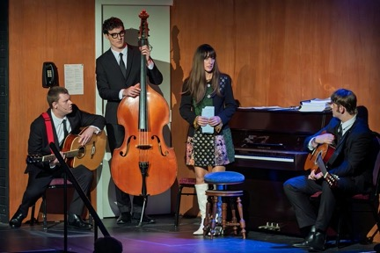
Production Team
Directors – Paul Belsham & Leanne Broadley
Assistant Director – Belinda Toth
Musical Director – Leanne Broadley & Paul Belsham
Vocal Coach & Vocal Director – Leanne Broadley
Choreographer – Belinda Toth
Costumes – Cast
Production Manager – Lynn Gough
CAST  JUDITH DURHAM – Leah Van Ewijk  ATHOL GUY – Logan Cartwright  KEITH POTGER – Gabe Dunwoodie-Halverson  BRUCE WOODLEY – Josh Watson  BEVERLEY SHEEHAN – Helen Petrie  BILL COCK – Allen Ennew  HAZEL COCK – Di Ennew  RON EDGEWORTH – Carl Moore  EDDIE JARRET/ROBERT WHITAKER – Trevor Stone  JOHN ASHBY – Peter Harding  DUSTY SPRINGFIELD/MITZI GAYNOR/DOLLY BIRD/DANCER – Belinda Toth  WAITRESS/DOLLY BIRD/DANCER/ENSEMBLE – Mila Hunter  POLICEMAN/TV HOST/SOUND ENGINEER, PRODUCER/SIMON DEE/GRAHAM KENNEDY – John Hannaford  DOLLY BIRD/DANCER/ENSEMBLE – Destiny Harding  ENSEMBLE – Cathy Puglisi  ENSEMBLE – Diana Mason | CREW  Lighting Design – Peter Harding  Lighting Operation – Karen Harding  Sound Design – Jonathan Pinnock  Sound Operation – Luke Mulder  Projection Design – Karen Harding, Liz van Eck  Projection Operation – Liz van Eck  Set Design – Paul Belsham  Set Construction – Paul Belsham & Peter Harding  Stage Manager – Lynn Gough  Stage Crew – Megan Elliott, Archie Mason-Reynolds, Jacquie McCalman  Props – Lynn Gough, Archie Mason-Reynolds  Wigs – Iesha Williams  Repetiteur – Leanne Broadley  Dresser – Ruby Day  Publicity – Liz van Eck  Headshots – Leah Van Ewijk  Program – Leah Van Ewijk  Front Of House – Malcolm Nott & Ballina Players  Special Thanks – Lynn Gough donation of Piano  BAND  Keyboard 1 – Leanne Broadley  Keyboard 2 – Warwick Binney  6 & 12-string guitar – Zach Walsh  Bass – Hudson Birden  Trumpet – Fiona Spinks  Drums – Paul Belsham

