ANNE OF GREEN GABLES
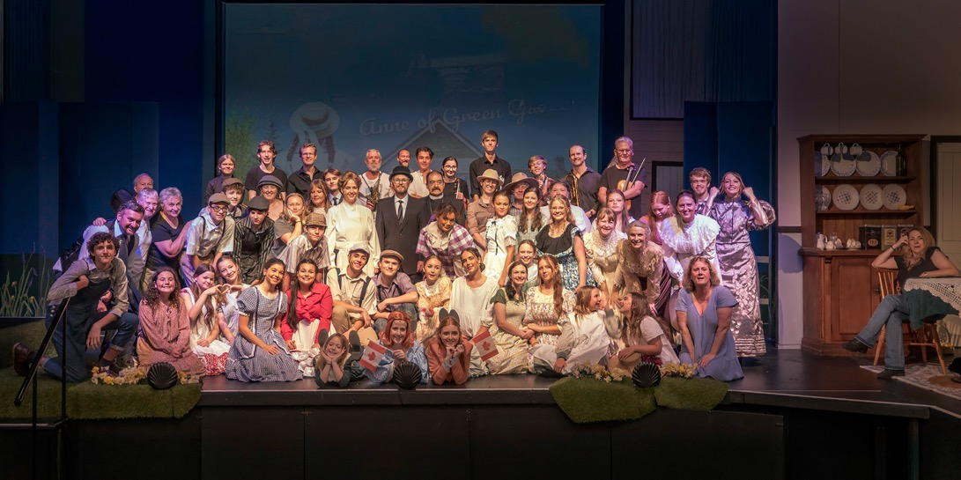
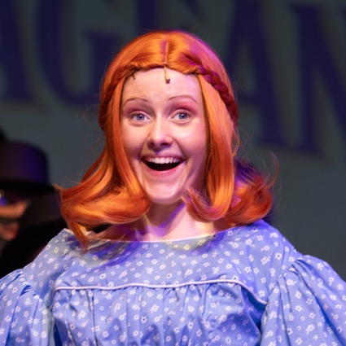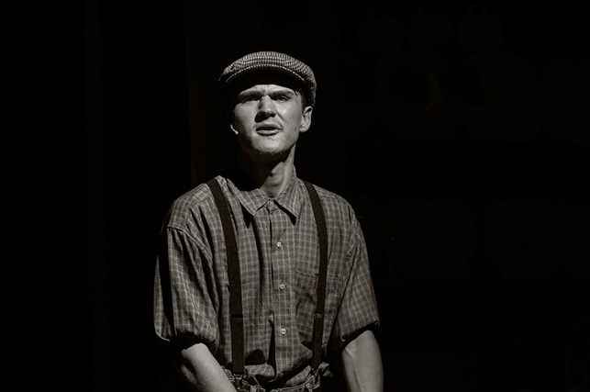
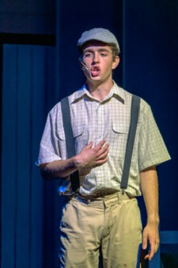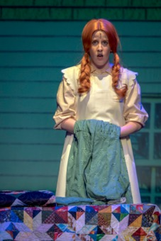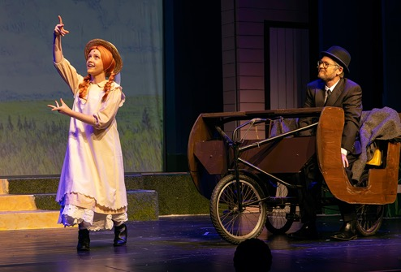
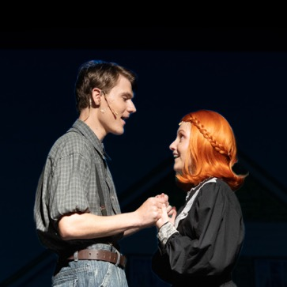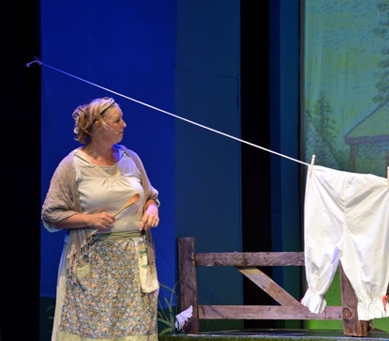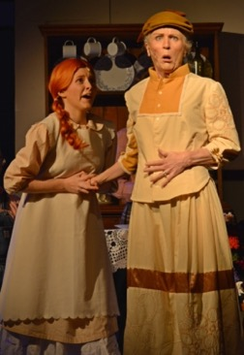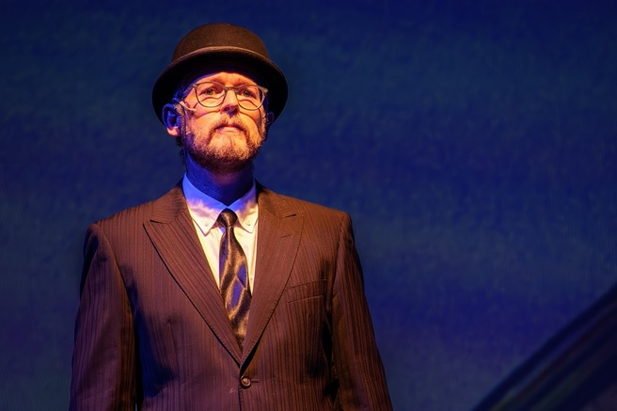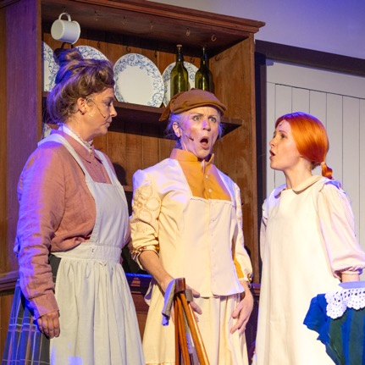
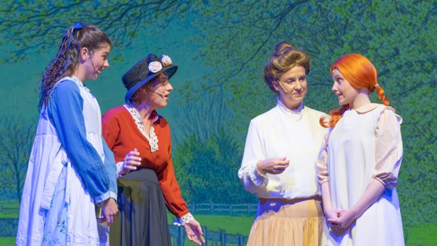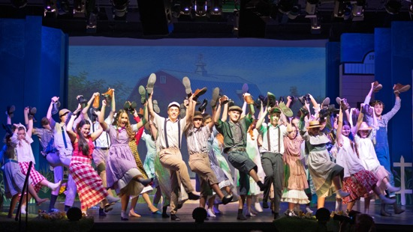
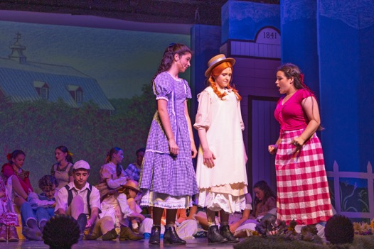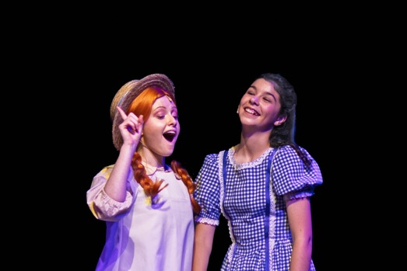
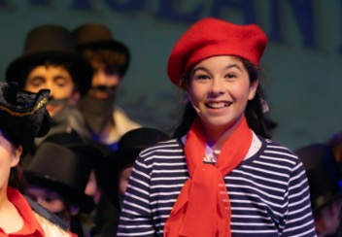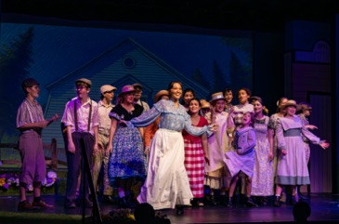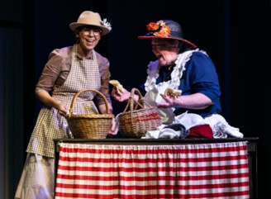
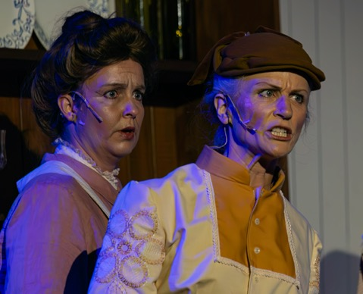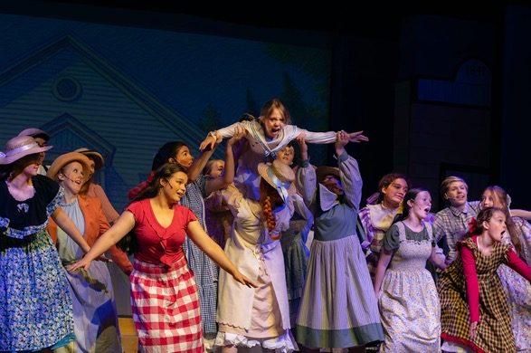
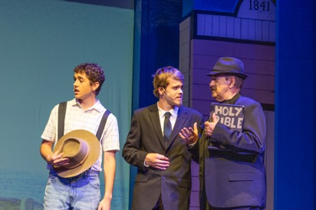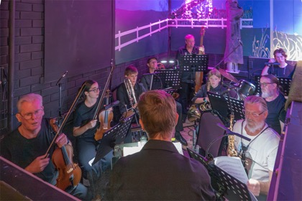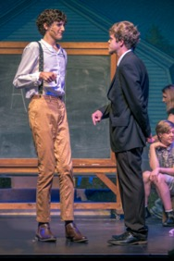
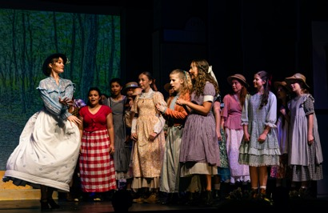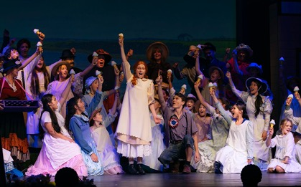
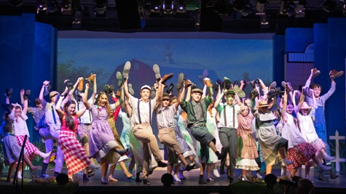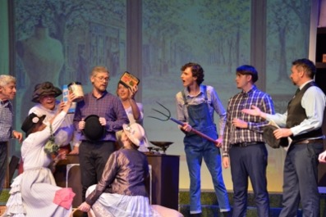
Production Team
Director – Jacquie McCalman
Assistant Director – Mechelle Anderson
Musical Director – Brendan Flanagan
Choreographer – Bethany Harm
Vocal Coach – Bev Peart
Costumes – Jacquie McCalman
Production Manager – Mel Doriean
CAST  ANNE SHIRLEY – Sophie Scott  ANNE UNDERSTUDY – Olivia Flanagan  MARILLA CUTHBERT – Suzanne Roberts  MATTHEW CUTHBERT – Darren Muller  GILBERT BLYTHE – Luke Corbett  GILBERT UNDERSTUDY – Zach Roberts  RACHEL LYNDE – Emily Wailes  DIANA BARRY – Anouk Hoskings  JOSIE PYE – Serena Troncoso  MISS MURIEL STACY – Lilli-Rose Sheen  MRS BARRY – Alicia Burton  MRS MACPHERSON – Olive Dowling  MRS SLOANE – Tee Ireland  MRS PYE – Kathryn McMillan  MRS BLEWETT – Megan Meany  THE MINISTER – Ian Chadderton  PRISSY ANDREWS – Lauren Cooke  RUBY GILLIS – Amelia Staader  TILLIE BOULTER – Olivia Flanagan  GERTIE PYE – Eden Mager  CHARLIE SLOANE – Zach Roberts  MOODY MACPHERSON – Xavier Amato  GERRY BUOTE – Phoenix Steveson  TOMMY SLOANE – Harvey Muller  MALCOLM ANDREWS – Toby Conlan  MR PHILLIPS – Oscar Puglisi  LUCILLA – Sharon White  THE STATIONMASTER – Luke Carrier, Gabe Dunwoodie-Halverson  CECIL – Rob Wansbrough  FARMER – Rob Wansbrough  EARL – Luke Carrier, Gabe Dunwoodie-Halverson  MAILMAN – Luke Carrier, Gabe Dunwoodie-Halverson  TOWN CHILDREN – Milla Harris, Charlie Carrier, Eva Skeet, Peyton, Holmes, Toby Meany, Imogen Anderson-Grace, Roxanne Anderson, Leilani Tiatia, Riley Cross, Archie Dempster, Stella Clark, Stella Wailes, Florence Muller, Ada Muller | CREW  DANCE CAPTAIN – Olivia Flanagan  SET DESIGN – Mechelle Anderson  LIGHTING DESIGN – Peter Harding  SOUND DESIGN – Jonathan Pinnock  VISION DESIGN – Mechelle Anderson  WIGS & MAKEUP – Iesha Williams  PROPS – Jacquie McCalman, Sharon White, Lynn Gough, Alicia Burton  SET CONSTRUCTION – Paul Belsham, Peter Harding  SCENIC ARTISTS – Tim Roberts, Sharon White, Mechelle Anderson, Tim Douglas,, Jacquie McCalman  PHOTOGRAPHY & POSTER – Mechelle Anderson, Lyn Gale  PUBLICITY – Liz van Eck, Iesha Williams, Mike Sheehan  PROGRAM & ILLUSTRATION – Leah Van Ewijk  STAGE MANAGER – Paul Belsham  STAGE CREW – Lynn Gough  LIGHTING OPERATOR – Peter Harding, Karen Harding  SOUND OPERATOR – Jonathan Pinnock, Luke Mulder  FOLLOW SPOTS – Karen Harding,  VISION OPERATOR – Peter Harding, Karen Harding  FOH – Malcolm Nott & Ballina Players Members  COSTUME MAKERS – Leanne Harrold, Jacquie McCalman, Alison Scott, Jude Evans, Rose Meany, Sophie Meany, Cast members  COSTUME COORDINATOR – Leanne Harrold  AUDITION PIANIST – Marie Caldwell  MICROPHONE SUPPORT – Destiny Harding  BAND  CONDUCTOR - Brendan Flanagan  VIOLIN - Michael McCabe, Maya Hockings  FLUTE/PICCOLO - Shaun Thomson  SOPRANO SAXOPHONE - Scott Cinnamon  FRENCH HORN – Cedar (Scott) Miller, Ebba Ryden  BASS - Hudson Birden  TROMBONE - Ian Smith, Nick Ryden  PERCUSSION - Isaac Flanagan

